**Student Name: Weight: 2.3%**

**Student ID:** **Marks:** **/15**

# Lab: Using Subqueries

## Equipment and Materials

For this lab, you will need:

* A Windows computer with a minimum of 16GB RAM and 250GB of free disk space, capable of nested virtualization
* Access to ORACLE SQL*PLUS
* Really Cheap Vacations Database created as part of previous learning activities
* Physical model for Really Cheap Vacations as created during previous learning activities

## Instructions

1. First, work through steps 2-5 individually. Then arrange a time to come together with your small group. As a group, create one solution based on the best individual script for each problem. Further refine the solution as a group as needed.
2. Use the existing Really Cheap Vacations database and physical model to complete this lab.
3. Review the Really Cheap Vacations Physical Model.
4. Review the Really Cheap Vacation Database.
5. Write a single script that satisfies all the requirements outlined in the Problem Set.

**Note:** Please do **not** include the code for the intermediate steps. The intermediate steps are provided as a roadmap showing one way that you could solve the problem.

1. Review the Tips for Success and Marking Criteria sections. Adjust your script as needed.
2. See Brightspace for exact due dates.
3. Only one submission is required per group. The submission should include:
   1. One script file
   2. One spool file showing all results
   3. One attribution list that outlines the activities associated with completing this assignment. A sample attribution list is provided on Brightspace.

## Problem Set

1. What is the most expensive tour (based on vacation_tours)?

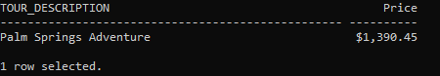

Possible intermediate steps:

* 1. What is the value of each vacation tour?

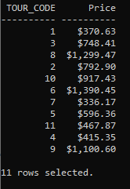

* 1. What is the value of the most expensive tour?

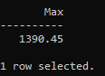

1. Which tours in Europe (tour_region is EU) are more expensive than **any** Canadian tour (tour_region is CA)?

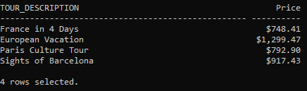

Possible intermediate step:

* 1. What are the prices of all the Canadian tours (tour_region = CA)?

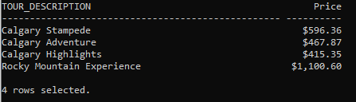

1. Show all tour destinations whose price is less than the average.

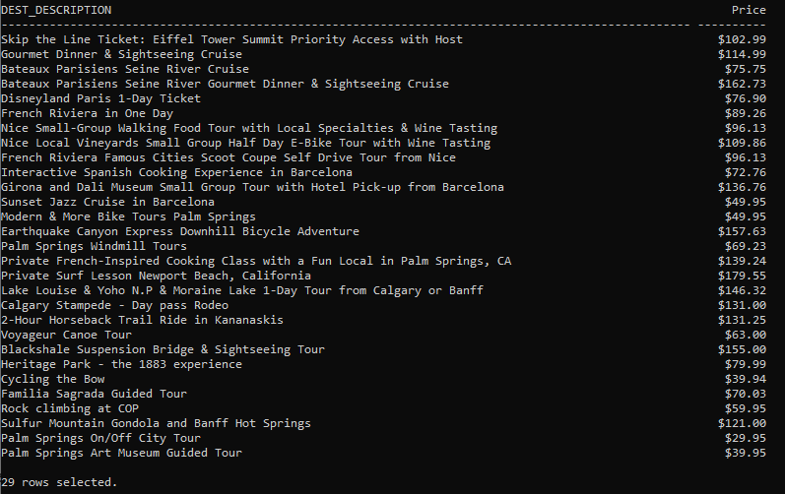

Possible intermediate step:

* 1. Construct a table with the average price. Include that table in the FROM clause of your final solution

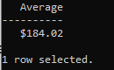

1. Which customers have taken the same vacation tours as Ethan Hunt's customers? Do not include Ethan's Hunt's customers in the list.

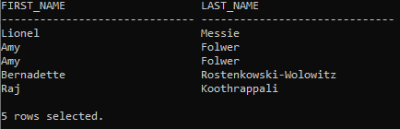

Possible intermediate step:

* 1. Make a list of all vacation tours for Ethan Hunt's customers.

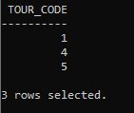

## Tips for Success

1. Use column aliases to create appropriate column headers.
2. Use **set linesize xxx**, where which xxx is a number to set the width for the output.
3. Use the column command to set the size of the columns, e.g.:  
   **column “aliasname” format A40**

**column stagename format A30**  
“A” means alphanumeric field, with a length of 30 characters in the example above.

1. For number columns use

**column “aliasname” format 9999.99**   
This will show four digits before the decimal point and two digits after the decimal point.

1. Use **clear columns;** at the end of each query to reset the column size.
2. Use the following format for breaks:  
   break on *columnname/alias* [on *columnname/alias*]

## Marking Criteria

|  |  |  |  |  |  |
| --- | --- | --- | --- | --- | --- |
| **Categories** | **Missing 0** | **Needs Improvement 1** | **Good 2** | **Excellent 3** | **Score** |
| Correct Results (e.g. # of rows, values) | N/A | 2+ questions incorrect | 1 question incorrect | Yes | **/3** |
| Output is formatted to match what is provided | No attempt to format output | 3+ formatting issues, lines wrap in output | 1-2 formatting issues | Yes | **/3** |
| Solution will work on all datasets (e.g. no hard-coded values) | 4 questions will not work for all datasets | 2-3 questions will not work for all datasets | 1 question will not work for all datasets | Yes | **/3** |
| Attribution list provided | No |  |  | Yes | **/3** |
| Spool file provided with commands included | No |  |  | Yes | **/3** |
| **/15** | | | | | |